Adam Mohmoud
AZ-900 Fundamentals
Virtual Machine with Powershell Lab
Mohmoud.adam@gmail.com

In this lab, I created a Virtual Machine (VM) with PowerShell in Azure entails using script commands to provision, configure, and manage virtual machines programmatically, providing flexibility and automation for VM deployment tasks.

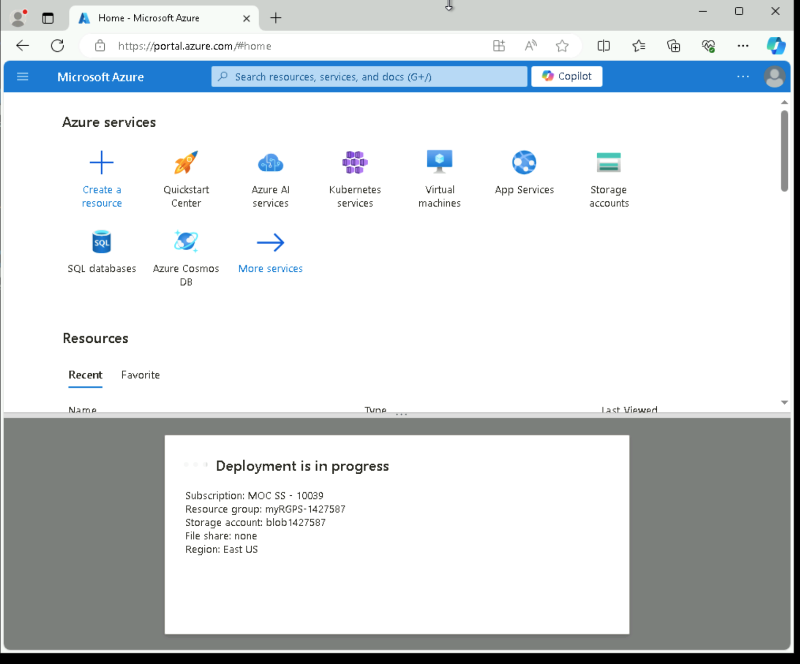

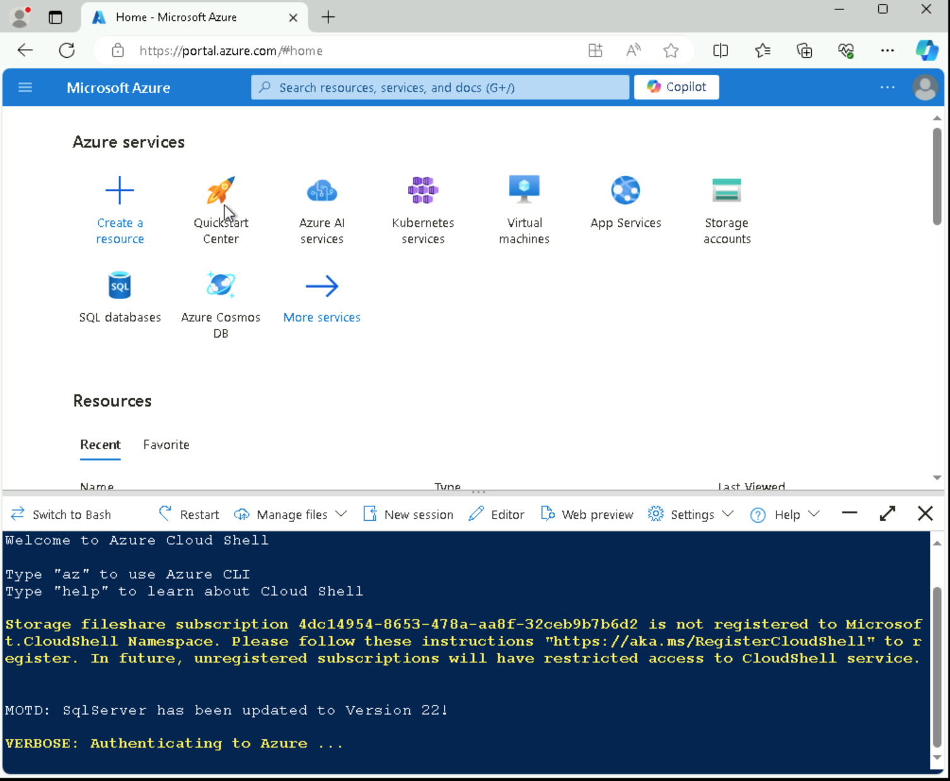

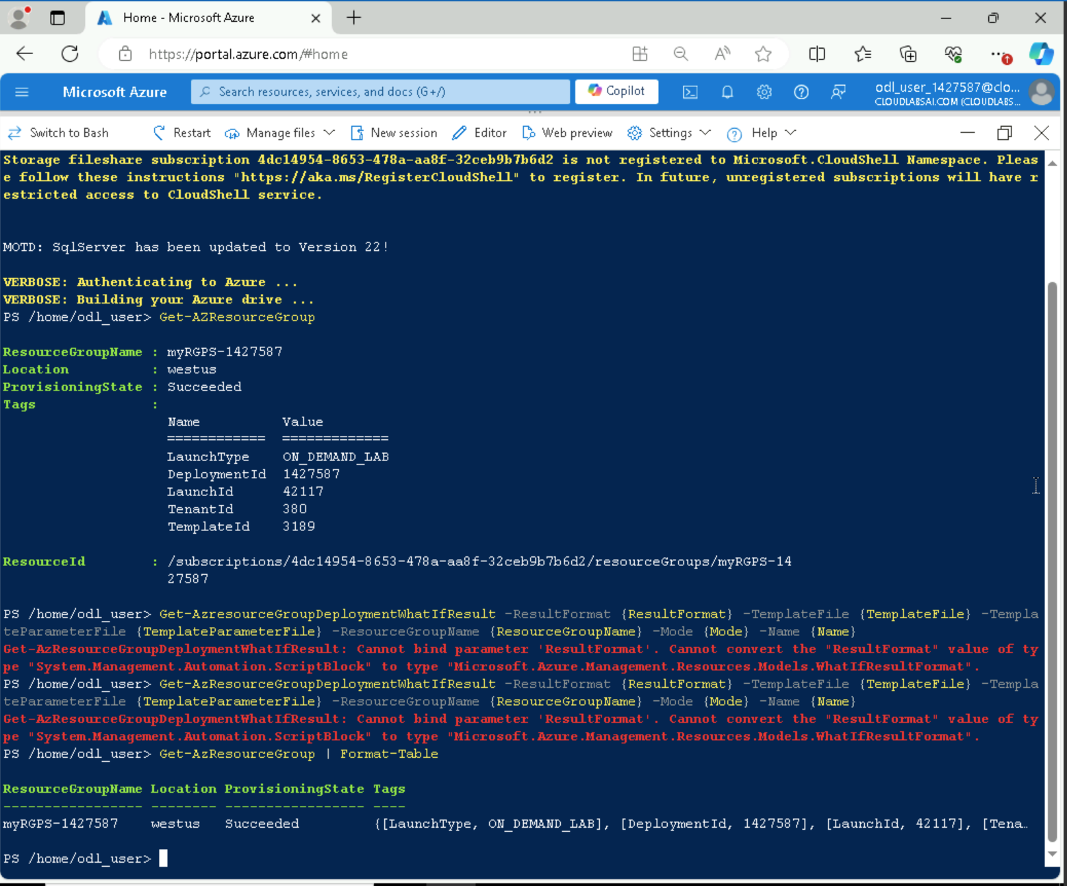

In powershell I located the existing resource group “Get-AZResourceGroup” and verified the resource group “Get-AzResourceGroup | Format-Table”. (Pardon the initial errors).
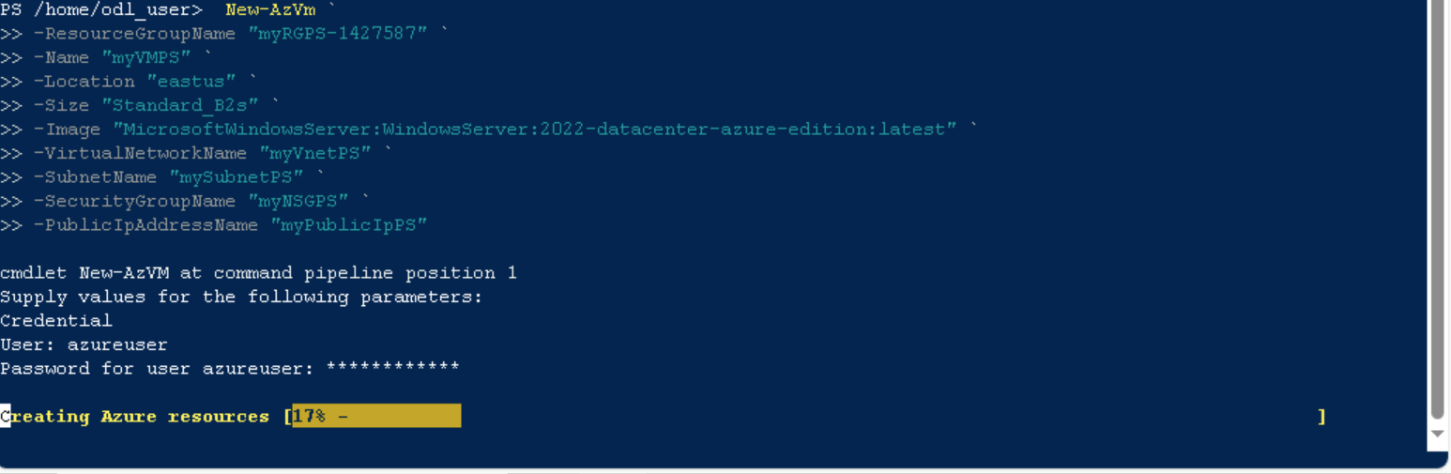
I proceeded with Creating the virtual machine, when prompted provide the username and the password. This will be configured as the local Administrator account on that virtual machine.
```
New-AzVm `
-ResourceGroupName "myRGPS-1427587" `
-Name "myVMPS" `
-Location "eastus" `
-Size "Standard_B2s" `
-Image "MicrosoftWindowsServer:WindowsServer:2022-datacenter-azure-edition:latest" `
-VirtualNetworkName "myVnetPS" `
-SubnetName "mySubnetPS" `
-SecurityGroupName "myNSGPS" `
-PublicIpAddressName "myPublicIpPS"

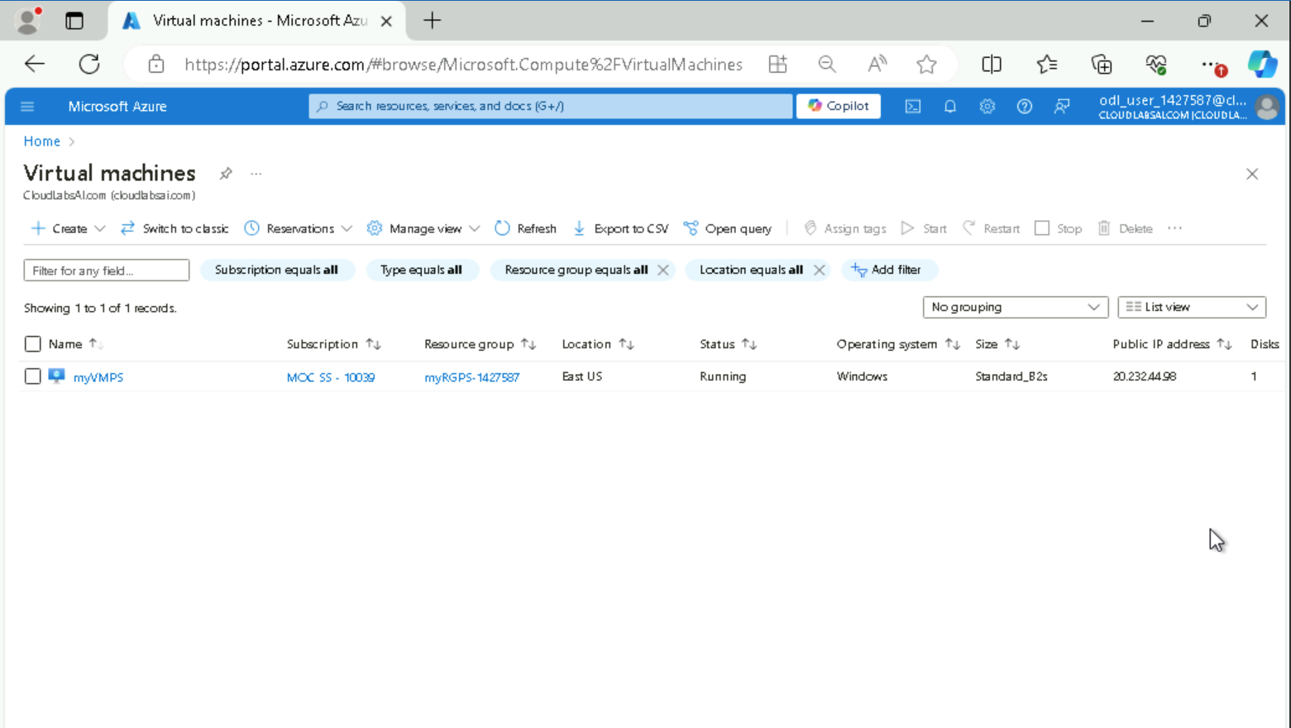
After closing the powershell session, I searched for the virtual machine in my Azure portal and verified that “myVMPS” is ‘running’.



